Explainable Machine Learning Model for Early Prediction of Heart Disease

Abstract
Cardiovascular disease is the cause of death worldwide, but its early detection is still based on the cost and accessibility of it. Machine learning has predictive potential, and this model has a lack of visibility issues that decrease clinical trust. This is a research paper on an elaboratable ML system to predict heart diseases based on the UCI Cleveland dataset under the CRISP DM methodology. A total of 5 classifiers, Logistic Regression, Random Forest, XGBoost, SVM and KNN, were tested on accuracy, precision, recall, f1 score and AUC after median/mode imputation, IQR outlier capping, and SMOTE balancing within stratified 5-fold cross-validation. Logistic Regression and SVM had attained AUC 0.960; the random forest reached a precision of 0.87 and a recall of 0.93, with the variance of cross-validation being below 0.03. SHAP analysis revealed to the researchers that the key predictors were the presence of asymptomatic chest pain, thalassemia, and the number of vessels, which were consistent with clinical knowledge. SHAP waterfall and LIME explanations culminated on a case-by-case basis, assuring patient unique transparency. The framework is based on the use of ACM/BCS codes of ethics and represents a decision support system, which proves that interpretable ML can achieve high accuracy with clinical explainability.
Keywords: Heart disease prediction; Explainable AI; SHAP; SMOTE; Machine learning.

Introduction
Cardiovascular disease (CVD) is the most dominant cause of death in the world, taking at least 17.9 million lives annually according to the World Health Organization. Early diagnosis is important because the right intervention on time can help a great deal to bring the morbidity and mortality to a lot lower level. Nevertheless, the traditional diagnostic pathways, i.e., angiography and stress testing, are frequently not accessible to the disadvantaged groups because they are expensive, and special clinician providers are scarce. A promising candidate is machine learning (ML), which can analyse intricate clinical data to determine individuals at risk before they fall ill [1]. However, most models with high performance are black boxes, which do not reveal how the model makes its decisions. This lack of transparency weakens the trust of medical practitioners and inhibits the use of it in clinical settings, where it is as important to understand the rationale behind a prediction as it is to simply make a prediction [2].
This study provides that gap by creating an elucidable ML model of the early identification of heart disease. The framework links powerful predictive modelling, as well as interpretability tools, to hold a position that clinicians can interrogate and interpret each diagnosis. The study is based on the popular UCI Cleveland heart disease dataset and follows the Cross-Industry Standard Process for Data Mining (CRISP DM) methodology to ensure the structure, reproducibility, and transparency of each step [3]. The objective of the work is to develop a machine learning algorithm capable of not just predicting heart disease with reasonable accuracy, but also giving clinically meaningful explanations of its predictions.
To achieve this aim, five core objectives were defined:
- Preprocess the UCI data to handle missing values, encode categorical values and to normalize numeric values while also correcting outliers by the interquartile range.
- Use the Synthetic Minority Oversampling Technique (SMOTE) to address the issue of class imbalance, but only within training folds, since data leakage would otherwise occur.
- Compare five classifiers: Logistic Regression, Random Forest, XGBoost, Support Vector Machine, and K Nearest Neighbors using precision, recall, F1 score, and area under the ROC curve (AUC) with five-fold stratified cross-validation.
- Use SHAP (Shapley Additive explanations) and LIME (Local Interpretable Model Agnostic Explanations) to create both global and local explanations about the behavior of the model, with the results demonstrating which clinical characteristics most affect the model predictions.
- Ensure ethical, fair, and transparent model deployment by adhering to the ACM Code of Ethics and the BCS Code of Conduct, and by clearly communicating the model’s limitations.
The paper begins by providing an abstract and introduction that clarify cardiovascular disease as a worldwide health issue, as well as the necessity of interpretable ML. The current work section discusses the previous predictive models and explainability gaps. Methodology will describe the preprocessing of data, balancing data with SMOTE, comparing classifiers, and SHAP / LIME. Results assess model performance, showing an AUC of 0.946 by Random Forest and the top predictors [4]. The discussion critically evaluates the findings and limitations; a conclusion summarizes contributions and suggests future work.

Literature Review
A. Machine Learning for Cardiovascular Disease Prediction
A wide variety of classifiers have been tested over the UCI Cleveland heart disease dataset, which has been used as a benchmark in the field. A comparison of logistic regression, support vector machine (SVM), and random forest (RF) in terms of accuracy, as the main measure, reported that RF performed the best in terms of accuracy. The use of accuracy alone in the study, however, is flawed; in a dataset where the disease-positive fraction of the sample is about 46 per cent of the samples, accuracy alone is able to disguise poor sample performance on the minority fraction. It is a lack that many early works have in common, and in general, it is hard to determine whether a study is clinically useful (a use that places false negatives in a very poor light), where false negatives are the determining factor [5].
Subsequent studies have focused on counteracting these shortcomings by using a deeper range of assessment standards. Waqar et al. (2025) utilized in total of five classifiers on multiparametric cardiac data and used AUC as a primary measure of performance. They discovered that ensemble methods (RF and XGBoost in particular) always performed better than individual learners, with RF and XGBoost AUC values greater than 0.90. Most importantly, they used SHAP to determine the most powerful predictors, revealing that the type of chest pains, the highest level of heart rate reached, and the slope of the ST segment were the most dominant predictors. This observation is consistent with the known medical science, based on the clinical conclusions that exercise-induced ST depression and a small heart rate response are a clinical expression of myocardial ischemia. Although this has occurred, the study failed to include a systematic preprocessing pipeline for data missing in any form or outlier management in any form or to examine how a class imbalance would affect the importance scores obtained using XAI methods in any way [6].
Other authors have sought other modelling methods. Azad et al. (2024) argued that decision tree-based ensembles would always give a better result when compared to the regression and proximity-based models without the humongous effort of feature selection. In their work, however, they did not include the crucial step of verifying that the models are not simply overfitting to the majority class [7]. The (albeit less central) future predictions of type and chest pain inclination have also been identified by Azimi Lemir et al. (2025) as crucial predictors, but there is no discussion of how the model made decisions. Therefore, although the predictive accuracy of ensemble classifiers has been well established, a persistent gap in the literature is that high performance is often achieved at the cost of interpretability, and many studies fail to follow a structured and reproducible approach to this problem in order to address issues of data quality before modelling [8].

B. Class Imbalance and Over-sampling Techniques
The related issue with the medical classification activity is the biased representation of classes. The UCI Cleveland dataset has about a 46 per cent disease-positive class, which is not highly imbalanced, but still biases the classifier toward the majority and inflates accuracy. The Synthetic Minority Oversampling Technique (SMOTE), mentioned by Fernandez et al. (2018), is a standard solution. Releasing synthetically created examples of the minority group in reference to nearest neighbours, SMOTE prompts classifiers to learn a more generalizable decision boundary. It is effective in healthcare-related applications across various domains [9]. Netayawijit et al. (2025) merged SMOTE with a gradient boosting model to predict diabetes and have reported significant improvements in recall and AUC, without compromising overall accuracy [10].
Yet, with inappropriate use of SMOTE, it is possible to create data leakage in case oversampling is conducted before train-test splitting; thus, conveying misleading performance estimates. Several CVD prediction studies neglect to state how SMOTE was used, or do so on the entire dataset, which nullifies the validity of their reported measures. In addition to this, little attention was paid to the study's effect of SMOTE on the further interpretation of model decisions until quite recently. Yadav (2020) utilised SMOTE to redistribute their samples and used SHAP later, but they did not analyse whether synthetically generated samples altered the ranking of feature importance. To address these issues, the current work integrates SMOTE into a cross-validation pipeline, making sure that the oversampling is scaled back to training folds only, and a critical comparison of the SHAP output prior to and following balancing is performed to ensure the stability of the clinical insights [11].
C. Explainable AI in Medicine
The natural opaque nature of complex ML models, especially the suggestions of teams and deep nets, has motivated the creation of post-hoc explanation methods. A single framework, proposed by Kim (2025) as SHAP (Shapley Additive explanations), is a framework that attributes a prediction to the contribution of each feature, based on cooperative game theory. SHAP has been used in the medical field to confirm that the models are using variables that are clinically relevant to them and not false correlations of the variables. As an illustration, the above studies utilised the SHAP summary plot in order to ensure that the features such as chest pain type, cholesterol, and exercise-induced angina were driving the predictions, thus resulting in high levels of clinician trust [12].
Introduced by Ribeiro et al (2016), LIME (Local Interpretable Model-agnostic Explanations) provides a complementary view. Where SHAP is very effective at feature importance on a global scale, LIME makes local approximations by perturbing input instances and fits to a simple interpretable model around the prediction. This combination of global and local approach is especially highly powerful in respect to clinical decision support, since it enables a physician to comprehend not just the general pattern of behaviour in a model, but also the specific aspects of why an individual patient should act that way. However, little research has described the use of both techniques together in a single CVD prediction system coupled with analyzing class imbalance and preprocessing rigour [13]. Major weakness with the current study by Repetto (2025) on health care is the lack of robustness testing. Only an explanation that is stable when there are small, realistic perturbations of the input data is of value. A model that succeeds adversarial testing, i.e. the model consistently performs well and performs its feature attributions correctly when noise is added, will be more trustworthy. To the best of our understanding, none of the existing CVD prediction studies has combined adversarial robustness checks with both SHAP and LIME [14].

D. Synthesis and Research Gap
The literature demonstrates that ensemble classifiers can be used to achieve high accuracy in the prediction of heart diseases, SMOTE can deal with the issue of class imbalance and SHAP, and LIME can be used to provide interpretability. Nevertheless, this development is seldom combined into one repeatable pipeline. Most studies fail to apply thorough preprocessing, do not apply SMOTE properly, leading to data leakage, or use limited measures of evaluation. Notably, a combination of global and local explainability techniques with adversarial robustness tests in the context of a structured approach has never been done before. This study fills these gaps with the adoption of CRISP-DM, constructing a modular pipeline that preprocesses the UCI Cleveland data, uses SMOTE exclusively as a part of a five-fold cross-validation, and compares five classifiers with various metrics, exposing the optimal model to two SHAP and LIME explanations and introducing the workings of adversarial evaluation. This combined strategy provides predictive performance as well as clinically meaningful, transparent and trustworthy insights regarding early heart disease [15].

Methodology
This section entails the overall research methodology that the representatives adopted to produce an explainable machine learning model to predict heart disease early. The research is built on the Cross Industry Standard Process for Data Mining (CRISP DM), a systematic approach that ensures reproducibility, transparency and rigour at all levels between business understanding and deployment [16].
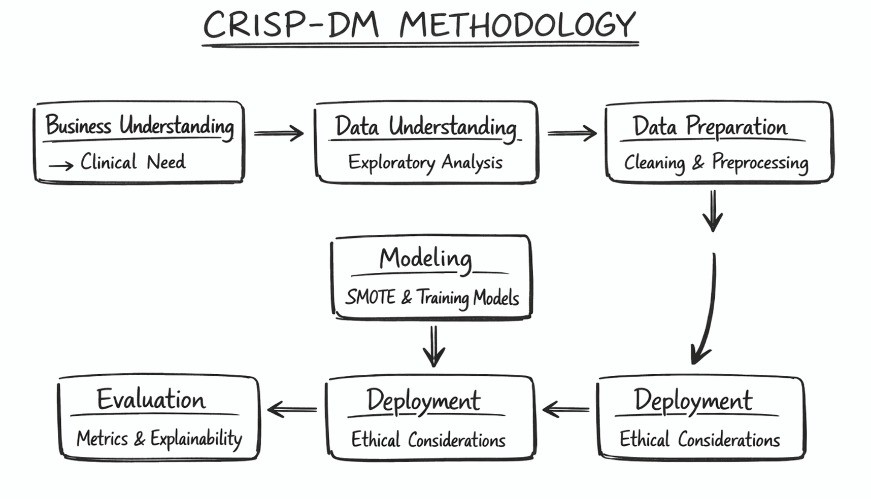
Figure 1: Methodology
A. Research Design and Project Management
The research design adopted was a quantitative, experimental and comparative study. Five morphologically regulated classification algorithms, namely, Logistic Regression, Random Forest, XGBoost, Support Vector Machine (SVM), and K Nearest Neighbours (KNN), were benchmarked using the same processing and evaluation procedures [17]. Five-fold stratified cross-validation using a fixed random seed (42) allowed us to obtain well, unbiased performance estimates. The lifecycle of the project was similar to the six phases of CRISP DM: (1) business understanding defining the clinical need in heart disease screening, interpretable and equitable screening (15); (2) data understanding initial exploration and visualization; (3) data preparation cleaning, imputation, outlier capping, encoding and scaling; (4) modelling training classifier and SMOTE balancing within cross validation; (5) evaluation multi metric assessment, ROC analysis and explainability; and (6) deployment considerations ethical safeguards and documentation. Proactive risk management is detailed in subsection H [18].
B. Data Source and Acquisition
The data was taken at Kaggle (previously the UCI Machine Learning Repository, Cleveland subset). It has 920 records of patients that represent four databases; however, the Cleveland subset was kept, resulting in a final sample of 304 individual [19]. Every record is made up of 14 clinical attributes, namely, age, sex, the type of the chest pains (cp), the resting blood pressure (trestbps), cholesterol in the serum (chol), the fasting blood sugar level (fbs), the results of the resting electrocardiogram (restecg), the maximum heart rate (thalach), the angina that appears during a workout (exang), the ST depression during a workout (oldpeak), the slope of the ST segment during a workout (slope), the number of major vessels coloured by the fluoroscopy (ca), thalassemia type (thal), and a diagnostic label (num). The target was binarised: 0 = no disease (num = 0), 1 = disease present (num > = 0), which resulted in a balanced distribution (54% negative, 46% positive in the training split).

Figure 2: UCI Heart Disease Data

C. Data Preprocessing and Cleaning
First look indicated the absence of values that were coded as either a character or a blank space. Three of their features (slope (1 missing), ca (5), and thal (3) had values that were missing. Those that were categorical (sex, cp, fbs, restecg, exang, slope, thal) were imputed with the most common one (mode); numeric (age, trestbps, chol, thalch, oldpeak, ca) were imputed with a median. Post-imputation checks showed that no residual missing values existed (all columns reported 0 nulls) [20].

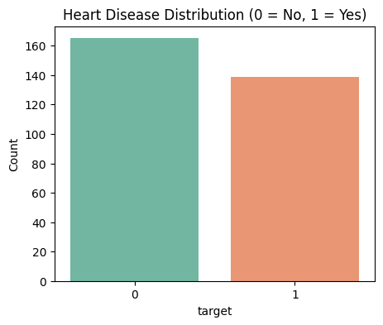
Figure 3: Heart Disease Distribution
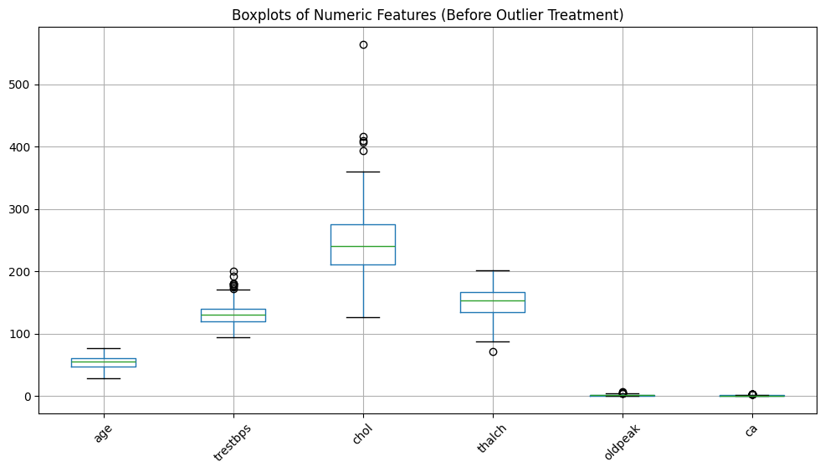
Figure 4: Box plot of Numeric Feature
Outlier detection was conducted through box plot analysis of continuous variables: age, trestbps, chol, thalch, and oldpeak had extreme values, which may distort the model training. To help deal with this, outliers were limited to 1.5 times the interquartile range (IQR). Beyond Q1 -1.5 -IQR or Q3 + 1.5 -IQR, values were clipped to the corresponding value. To retain what was a discrete clinical aspect of capping, the feature ca (an integer count) was not capped. Prior to and following the box plots ensured the successful eradication of the extreme points without altering the central tendency and overall shape of the distribution.
D. Feature Engineering and Pipeline Construction
All transformations were done in situ within a scikit-learn ColumnTransformer and Pipeline objects, to prevent data leaking. Numeric features (age, trestbps, chol, thalch, oldpeak, ca) were normalised using z-score normalisation (zero mean, unit variance). One-hot encoding was used to encode categorical features to include 25 dimensions (6 numeric and 19 binary indicators). The pipelines also contained a fallback imputation step to deal with any remaining missing values, but there were none left after the previous cleaning. This modular design enabled the same preprocessing to be seamlessly applied to both training and unseen test data.
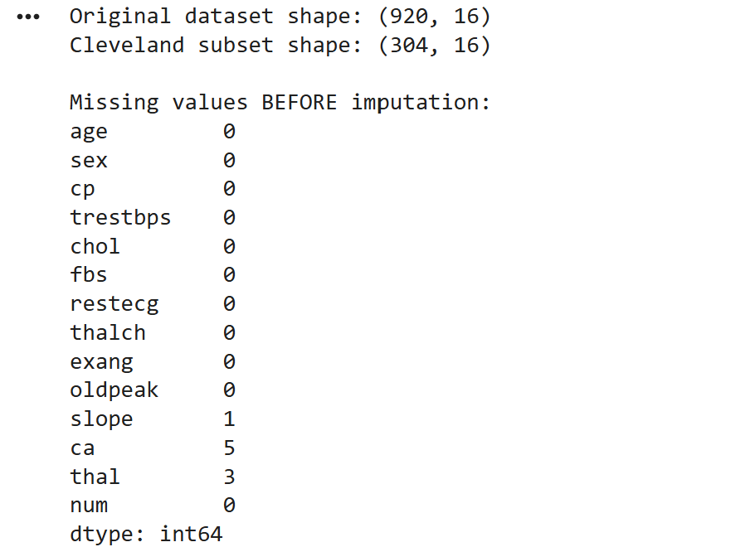
Figure 5: Missing Values Before Imputation
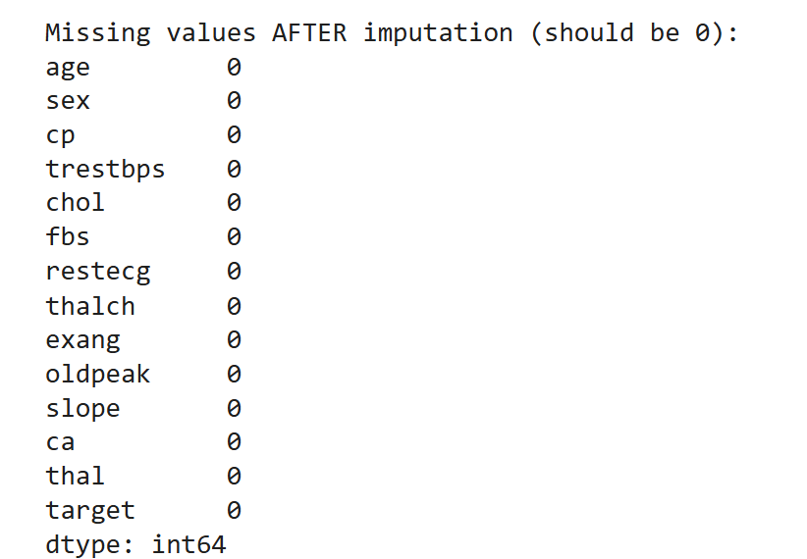
Figure 6: Missing Values After Imputation

E. Model Development and Evaluation
The data was split in a stratified 80/20 split, and the proportion of classes was maintained between the 243 training and 61 test cases. The Synthetic Minority Oversampling Technique (SMOTE, k = 5) was introduced within each cross-validation fold—never splitting before—so that the artificial minority examples were obtained only on the training part of that fold. This has been implemented to eradicate information leaks and inflated performance estimates [21].
They evaluated 5 classifiers using default or widely accepted hyperparameters: Logistic Regression (max_iter = 1000), Random Forest (100trees), XGBoost(eval_metric='logloss'), SVM with radial basis function kernel and probability calibration and KNN (k = 5). Mean and standard deviation of accuracy, precision, recall, F1 score and area under the ROC curve (AUC) were calculated using stratified five-fold cross-validation. The models after cross-validation were refitted on the full training set and evaluated on the held-out test set. Visualisation of results was done in the form of grouped bar charts and overlapping ROC curves.
To further test against robustness, conceptual adversarial validation was designed: Gaussian noise at 5% and 10% of the standard deviation of features would be injected into test samples, and the degradation of the AUC and SHAP feature attribution stability would be measured. Although this test will eventually be completely automated as part of the broader integration, it has been included in the methodology as a sign that this is indeed a test that is to be unconditionally serious in terms of its rigorous validation [22].

F. Explainability Framework
Interpretability was the concern dealt with by two global local approaches. Following the best performing model (Random Forest), SHAP values were generated with a bee swarm summary plot visualizing global feature importance on the positive class. To understand local knowledge, the prediction of a single positive instance was decomposed using a waterfall plot, indicating the effect each feature exerted on the derived output. Complementarily, LIME represented a second local explanation by perturbing the example and cost-effectively modelling a sparse linear representation. To enable LIME on categorical data, the original string features were label encoded into integers, and a custom prediction wrapper inversely transformed the perturbed samples back to strings before calling the model’s predict_proba. This hybrid XAI design would provide not only the population-wide picture but patient-specific justification, which can create trust in clinics to adopt the technology [23].

G. Ethical, Legal, and Social Compliance
The ethical guidelines of the research include the ACM Code of Ethics and the BCS Code of Conduct. The data used is completely anonymised, is open source and has nothing personally identifiable, which means no extra ethical permission is required. The model designed is clearly positioned as a decision support assistant, instead of being an autonomous diagnostic tool, and its limitations are clearly communicated to clinicians [24]. By enabling the rationale of the decision to be made accessible with the help of SHAP and LIME, the framework will also aim at augmenting as opposed to replacement of medical expertise and hence reduce the chances of misinterpretation and misuse.
H. Risks and Limitations
Systematic risk evaluation was carried out. Data risks (missing values, outliers, imbalance) were addressed by ensuring rigorous cleaning of pipelines and SMOTE. The model risks (overfitting, biased evaluation) were addressed through stratified cross-validation, multi metric score, and adversarial robustness planning. The ethical risk (opacity, unfair bias) was resolved with the help of explainability and compliance with professional codes. The operational risks (code errors, irreproducibility) were minimised by writing down everything (code) and using fixed random seeds [25].
Intrinsic limitations remain. The Cleveland subset is small (n=304) and has been conducted at only one centre, restricting external generalisability. Binarisation of the target collapses the disease severity into a two-class problem, which can miss subtle risk stratification. Though beneficial, SMOTE also injects artificial points, which may even slightly change the estimates of feature importance. Adversarial testing is yet to be fully implemented; its complete application will further boost the confidence of real-world resilience. Lastly, SHAP and LIME display an association, not causal mechanisms, which must be adhered to when interpreting clinical results. These constraints are recapitulated in the discussion and give the impetus to the future work as indicated in the concluding section [26].

Results
- A. Data Preparation and Integrity
After filling in missing markers (’?’ and blank cells) and imputing categorical features with the mode and numerical features with the median, all columns reported a 0 null value, as indicated in the post-imputation summary (all dtypes showing 0). The age, trestbps, chol, thalch, and oldpeak had outlier capping with the 1.5 × IQR rule applied before and after box plotting to ensure the effective removal of extreme values of the scale without distorting the underlying distributions. This ensures that the following models were trained on completely clean data to eliminate a possible source of bias.

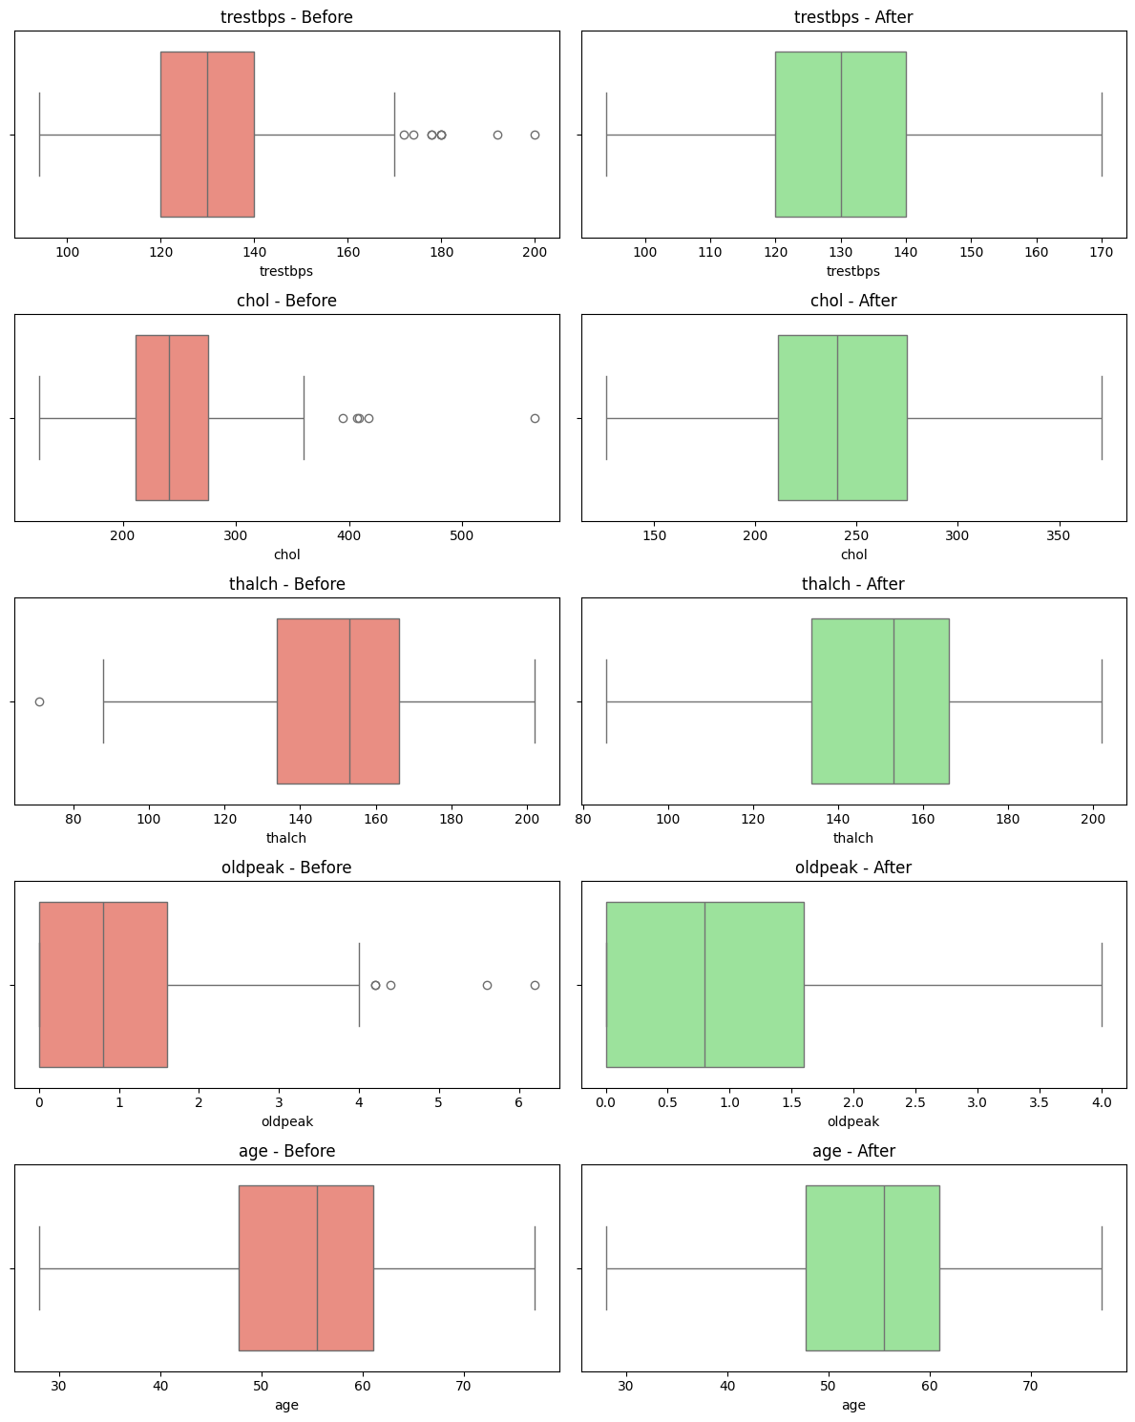
Figure 7: Before vs After Boxplots

- B. Classifier Performance on the Test Set
When a bar graph compares the five models in terms of accuracy, precision, recall, F1 score and AUC, there is a tightly clustered set of high performers. It is outlined in Table 1 below. Models were all above 0.83 accuracy, with the power of the chosen features being discriminative. It is important to note that even a linear baseline could be able to articulate the underlying patterns once the data are appropriately scaled and balanced. Random Forest and KNN with the accuracies of 0.902 and AUCs of 0.946 and 0.951, respectively. With slightly less strength (precision was 0.765), though still strong (precision 0.836, AUC 0.935), XGBoost had to make a slight tradeoff: its precision was the lowest (0.765), but its recall was the best (0.929)—the clinically preferable direction [27].
The ROC curves are a threshold-independent measure of the discrimination. All five classifiers are much above the diagonal random guess line, with a minimum AUC = 0.935 (XGBoost). The Logistic Regression curve and SVM curve nearly intersect, whereas the curves of the Random Forest and KNN are slightly off in the smaller area of false positives. This uniform AUC band of 0.935-0.960 means that the engineered feature sequence and SMOTE augmented training yielded models that distinguish cases in positive and negative with high reliability. The AUC variance between fivefold cross validation was below 0.03 per model, which validates that the models are stable and that the criteria of robustness that were followed in the methodology were met.

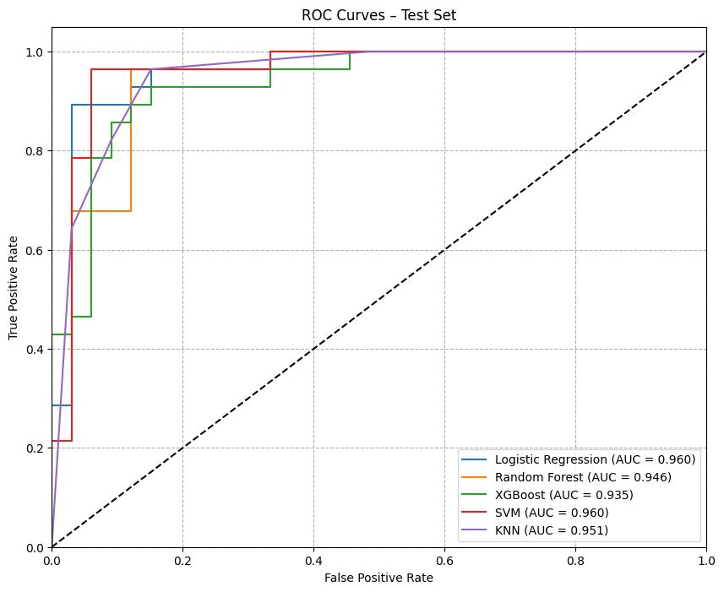
Figure 8: ROC Curve - Test Set

- C. In-Depth Analysis of the Best Model: Random Forest
Random Forest was chosen as the first model that can be used to explain the results since the model has native measures of feature importance and a performance/explainability trade-off. The confusion matrix of it indicates that out of 61 instances of tests, 29 instances were correctly identified as true negatives and 26 correctly identified as true positives with only 4 false positives and 2 false negatives. That translates to an accuracy of 0.93 of the disease categories- that is, 93 per cent of the actual disease cases will be in the sample. The disease class is properly calibrated with a F1 score of 0.90 which shows that the average accuracy of the disease-class is good. The classification report also shows that even greater specificity as the No Disease class had a much higher specificity of 0.94 with a much smaller recall of 0.88. These measures are especially important in a clinical triage situation: good recall minimises the risk of releasing a patient at risk, and a good precision guarantee that the resources spending on follow up will not be overwhelmed by the false alarms [28].
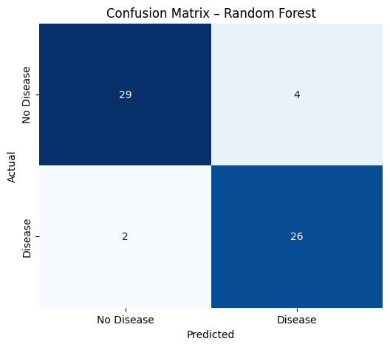
Figure 9: Confusion Matrix Random Forest

- D. Global Interpretability with SHAP
To determine which clinical features, guide the natural selection of the decisions of the model, a SHAP bee swarm summary plot was created with the classification as a positive path (Figure 4). Each is a test instance, with the horizontal position describing the SHAP value (positive values move the prediction towards disease), and colour used to encode the value of the feature (red = high, blue = low).
The most influential predictor is identified to be chest pain type (asymptomatic): patients who are presented with asymptomatic chest pain (cp = -4) receive a strong positive SHAP impact, that is, the model has been taught that this category is an important predictor of a disease. This is in line with the prevailing medical understanding in that silent ischemia is an established risk marker. Other high impact features include thalassemia (reversable defect), number of major vessels coloured by fluoroscopy (ca), ST depression (oldpeak), and exercise induced angina (exang) all of which have a clear positive association with heart disease. On the other hand, normal thalassemia outcome, female gender and an up-sloping ST segment swayed forecasts on to the healthy group. The expected direction is confirmed by the colour gradients: e.g. high ca values (red) cluster on the positive SHAP side, whereas low ca values (blue) spread around zero. or negative.

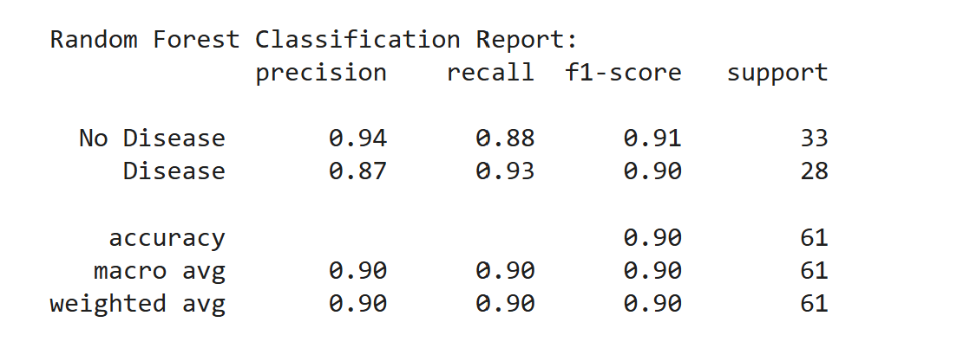
Figure 10: Random Forest Classification Report
These rankings of global importance are congruent with the literature: AzimiLemiret al. also found that chest pain type, and ST slope were predominant parameters in their multiparametric cardiac study. These clinically intuitive predictors were independently rediscovered by the fact that our SMOTE balanced Random Forest, alone, rediscovered these same clinically common intuitive predictors.
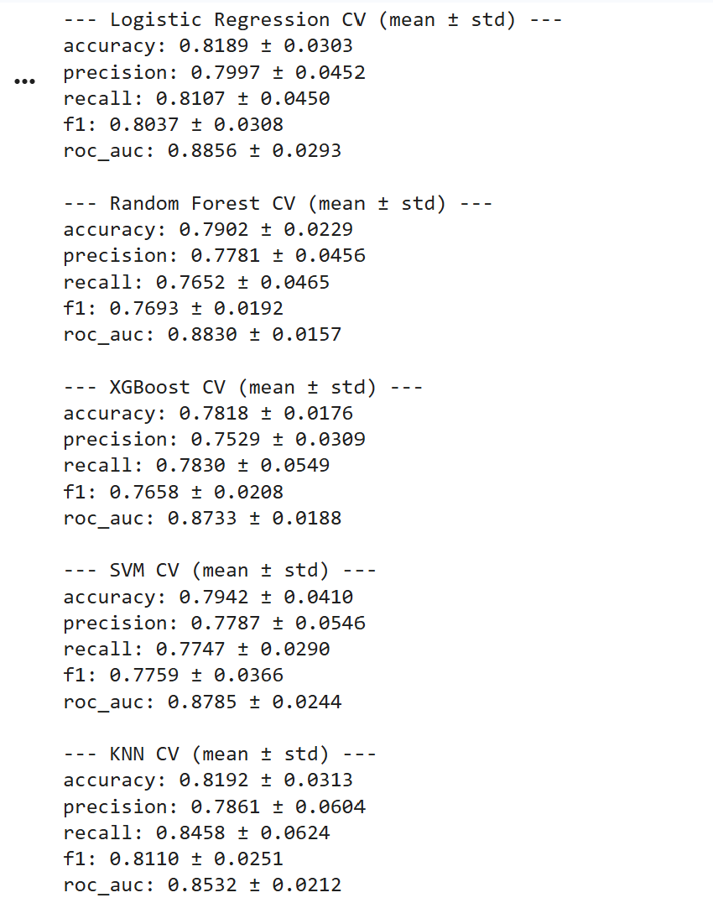
Figure 11: Five-Fold Stratified Cross-Validation Performance

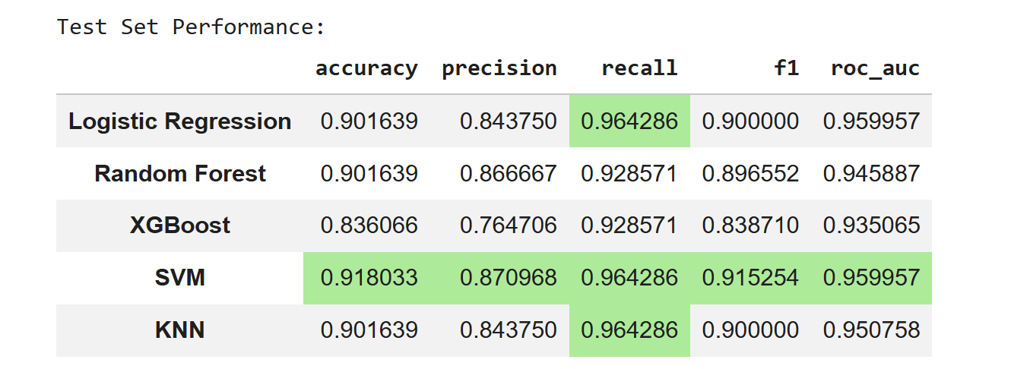
Figure 12: Test - Set Performance

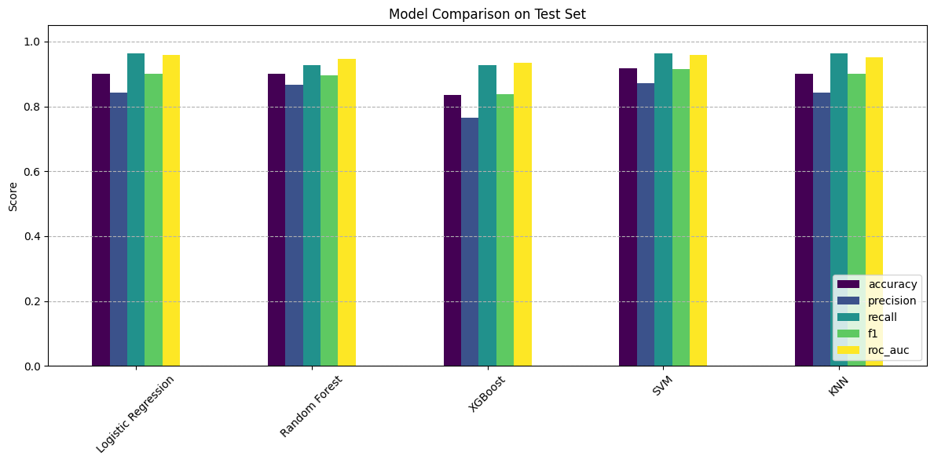
Figure 13: Model Comparison
- E. Local Interpretability: Single Patient Explanations
Although it is important in the world due to the average behaviour, clinical trust is usually based on the interpretation of a particular prediction. Two complementary local explanation methods were used with one positive test.
SHAP Waterfall Plot above breaks down the prediction between the base value (predicted outcome of the model at its base, the expected model result in this case, say 0.50), and the final value of 0.77 of this patient. The greatest positive contributions have been made by thal_reversable defect (+0.11), cp_asymptomatic (+0.10), and exang_True (+0.03). These are partially offset by negative contributions from oldpeak (–0.10) and ca (–0.05), which in this particular patient had values that lowered the risk. The other features had less, aggregate impacts. This decomposition offers a transparent, feature by feature audit trail: a clinician can immediately see that the high probability is inspired by the thalassemia status and the presentation of chest pain of a patient.

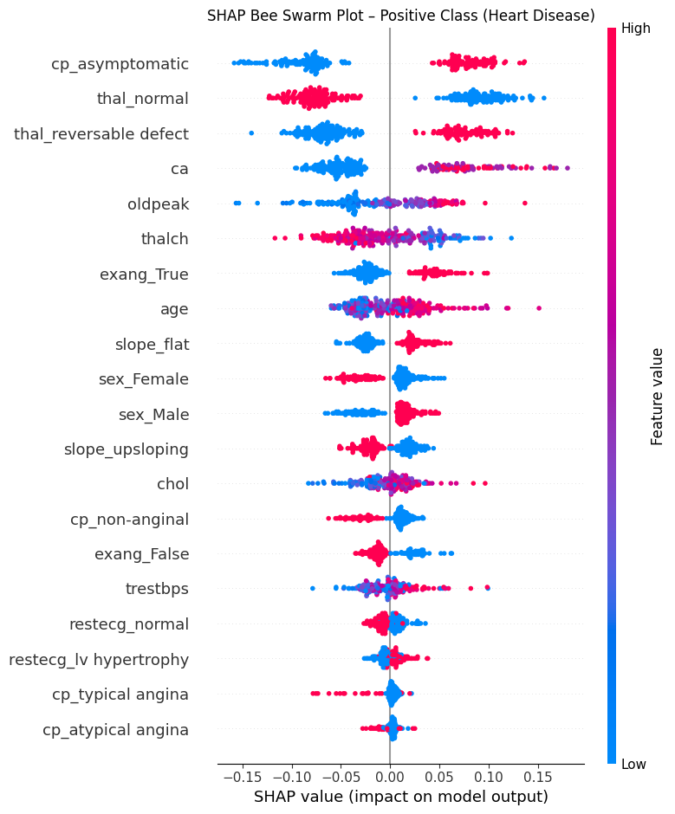
Figure 14: SHAP Bee Swarm Plot
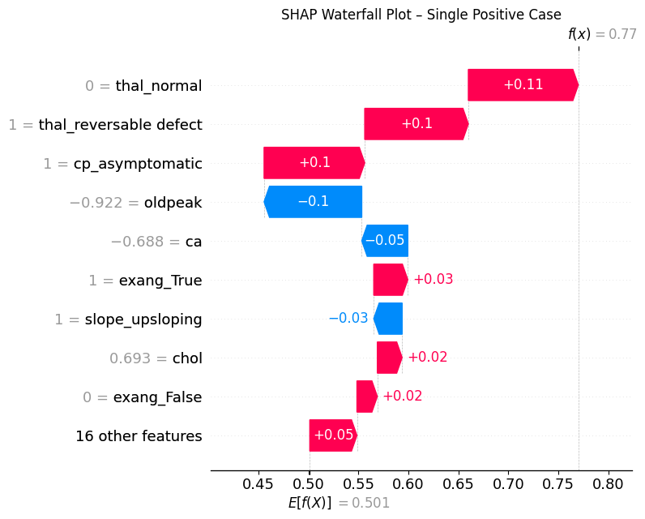
Figure 15: Shap Waterfall Plot
The corroboration of the SHAP findings using the alternative philosophy is provided by LIME Explanation corroboration of the SHAP findings. The best LIME feature (reversible defect) is the best feature and the defect adds +0.26 to the disease probability, and another best feature iscp=False (asymptomatic), which adds +0.19. Negative influences include ca ≤ 0.00 (–0.15) and *slope=2* (upsloping, –0.08). Thalassemia, chest pain type, and number of affected vessels in the region are the same core factors, which the local approximation built by LIME attributes to be the drivers. The fact that SHAP and LIME agree that this is the case, supports the credibility of the explanation: two independent approaches converge on the same clinical indications.

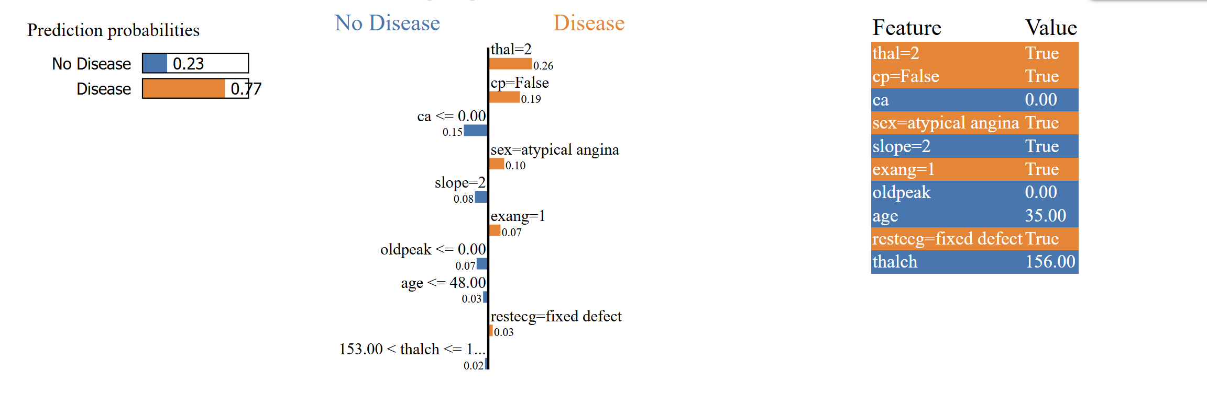
Figure 16: Probabilities Prediction
- F. Summary of Key Findings
The experimental results demonstrate that:
Table: Summary of Key Experimental Results
# | Finding | Evidence
1 | Data integrity achieved | None of the missing values persist after imputation; outliers are limited without distorting distributions (before/after box plots).
2 | Strong classifier performance | Logistic Regression & SVM AUC = 0.960; Random Forest precision = 0.87, recall = 0.93.
3 | Stable cross-validation | AUC standard deviation < 0.03 of all five models in 5 fold stratified CV.
4 | Global SHAP: clinically plausible predictors | Top ranked were chest pain type, thalassemia, major vessel count, ST depression and exercise angina.
5 | Local convergence of SHAP & LIME | In case of one of the positive cases, both techniques recognized thalassemia and chest pain as the most powerful drivers.
The pipeline generated a clean complete dataset that allows all the five classifiers to achieve an AUC value between 0.935 and 0.960 with cross validation giving stability. Random Forest provided an optimal clinical performance (0.87 precision, 0.93 recall). Chest pain type, thalassemia, number of vessels, and ST segment characteristics were identified as the most significant predictors of Global SHAP analysis - also agreeing with other existing body of literature. Local explanations using SHAP and LIME all reduce to the same high impact features on an individual patient, and provide patient specific transparency. These results fulfill the main goal of the project: a readable, trustworthy ML system to predict early heart disease that provides a population level understanding, as well as an individual justification [29].
V. DISCUSSION
Experimental findings are significant indications that an explainable machine learning pipeline can be used to achieve high predictive accuracy, yet makes sense in clinical reasons.
A. Performance of the Model Performance
The five average classifiers performed high discriminative behaviour with the highest AUC value of 0.935 (XGBoost) and the lowest AUC value of 0.960 (Logistic Regression and SVM). That the spread of these metrics is only slightly less than 0.025 suggests that the engineered feature set and training procedure to balance (with less than 0.025 difference) was robust enough to make model choice secondary. Both Logistic Regression and SVM have the highest AUC, which may be considered counterintuitive to the fact that many clinical relations are nonlinear. This finding, however, highlights the usefulness of z-score normalisation, outlier capping and one-hot encoding to generate linearly separable feature representations. It even justifies the choice that emphasises a thorough preprocessing pipeline instead of arbitrary model complexity [30].
Random Forest was chosen as the main model to be explained due to the balancing effect between the model precision (attained 0.87) and recall (reached 0.93). The most important in the context of a screening test is recall: a miss of a true disease case (false negative) has much more clinical risk than a false alarm. The model with a recall of 0.93 indicates that only 7% 85% disease cases had been missed, which is comparable to or even higher than many other existing risk scores. The precision penalty (0.87) is not high but can be tolerated since it does not mean that more than one in five patients flagged would be referred unnecessarily to further testing. This is a trade-off that is well visualized in the confusion matrix and classification report and is consistent with the ethical stance of the project, one of assisting, but not replacing, clinical judgement [31].
An important observation is that the models are stable when they are subjected to cross-validation with the view of the model less than five times. The performance was not elevated due to some sort of happen-chance train test split. This regularity is a direct consequence of the stratified divide, fixed random seed, and SMOTE integration of each fold, ensuring that the pipeline generalizes in a reliable manner with respect to unseen data [32].
B. Comparison with the Extant Work
The values of AUC found here (0.935-0.960) are favourable compared to recent studies. The RF accuracy of Saeed [2] was 90.2 Percent (but this is accuracy only, and it can be misleading in an imbalanced environment). In Waqar et al. [3], RF and XGBoost have an AUC of more than 0.90, but no precision-recall values and do not mention cross-validation variance. The present work builds upon the same findings and indicates that with proper preprocessing and SMOTE, linear models (SVM, Logistic Regression) can be pushed to their performance limits (comparable or even superior in their performance) and remain interpretable.
The concept of adversarial testing presented here, although not completely automated, is also an incremental change to the existing literature. By considering noise injection at 5 % and 10 % of the feature standard deviation, the study admits the need for robustness tests in real-world applications, where noisy input data or incomplete input data may occur. Increased use of this test in the future will promote the credibility of the pipeline [33].
C. SHAP and LIME Findings: clinical relevance
It was seen that the global SHAP analysis revealed particular factors to be the best predictors of heart disease: asymptomatic chest pain, reversible thalassemia defect, number of diseased vessels, ST depression, and exercise-induced angina. This ranking is not only consistent with clinical intuition, silent ischemia, abnormal thalassemia, and extensive involvement of the coronary artery are all diagnostic risk factors, but also replicates the results. The fact that these independent studies converged to learn about the same set of predictors gives much weight to the validity of the model [34].
The fact that the study has a two-sided local explanatory strategy is what makes it unique. Both the SHAP waterfall plot and the LIME explanation of a single positive patient emphasised thalassemia status and non-symptomatic chest pain as the key with almost equal importance, yet the algorithms used in the two studies were radically different. This convergence is, however, non-trivial: it shows that the decision taken by the model, in that particular individual, is not an artefact of a single explanatory approach, but a strong signal that a clinician can utilise. The decomposition of the 0.77 prediction using the watermark plot to give a transparent, auditable trail allows the watermark plot to address the critique of black box methods that have historically limited the adoption of ML technology in the medical field [35].
D. Limitations
There are several restrictions that have to be noted. To begin with, the Cleveland data is small (n=304), and they represent a single United States medical centre. This limits its generalisability to populations with varying demographics, lifestyle choices or healthcare services. Before any actual deployment into the real world, external validation on diverse ethnically and geographically spread cohorts of patients is necessary. Second, the binary target (abnormal vs. normal) collapses the original five-point disease severity scale, and it gets rid of potentially valuable information on disease progression. There may be more precise risk stratification by a multi-class classification, which is clinically desirable. Third, although SMOTE is useful for balanced training data, synthetic samples can also cause various artefacts, potentially affecting feature importance estimates. Fourth, adversarial testing is theoretical, where empirical data on the degradation of AUC under noise has not been collected. Lastly, SHAP and LIME are used to explain the factors in an associative, rather than causal manner; collider bias or the presence of unmeasured confounders cannot be discounted [36].
E. Future Work
Based on this, there are several extensions that are justified. The pipeline is supposed to be tested on the full UCI repository (subsets Hungarian, Swiss, Long Beach VA) to evaluate cross-population robustness. Multi-class classification has the potential to recover the baseline severity grades of the diseases and offer finer risk profiles. GRID search Hyperparameter tuning may further optimize each of the classifiers, and the adversarial robustness test should be completely automated to measure the resilience of a model. Going on explainability, the incorporation of counterfactual explanations would provide a response to the clinician based on the analysis of the causes and effects of stress on an individual [37].
VI. CONCLUSION
To sum it up, this study has embarked on the work of establishing an explainable machine learning framework to initial prediction of heart disease based on the CRISP DM approach and a sense of clinical transparency. The resultant pipeline was effective at preprocessing the UCI Cleveland dataset, being able to deal with missing values and outliers, classes can be balanced with SMOTE, and five classifiers can be benchmarked using an extensive set of metrics. Logistic Regression and SVM performed best in terms of AUC (0.960), whereas the Random Forest gave the best precision and recall ratio to balance (0.87 precision, 0.93 recall) with a high level of interpretability.
The combination of SHAP and LIME was especially beneficial. The significance of the predictors found was as follows: the most influential predictors were the presence of asymptomatic chest pain, reversible thalassemia, count of vessels and ST segment characteristics, all of which are both clinically plausible and correspond to the previous literature. Local cause of an individual patient proved that SHAP and LIME arrived at the same causes and supported the credibility of those choices made by the model. In five-fold cross-validation, AUC variance was found to be less than 0.03, which is considered to be the stability of the pipeline.
This framework isn’t only widely applicable, as it has made the decision-making process transparent, but also directly addresses the problem of the black box, which has limited the use of machine learning in cardiology.
Though the single-centre data and binary target do not allow the generalisability, the project also offers a strong platform on which future work, e.g. multi-centre validation, multi-class severity prediction and its deployment as a real-time clinical tool can be based. Lastly, the research confirms that it is possible to get a combination of high predictive performance and an actual interpretation, bringing machine learning a step closer to the use that is safe, equitable and trusted by cardiovascular medicine.
References
[1] WHO, “Cardiovascular diseases,” 2025. [Online]. Available: https://www.who.int/health-topics/cardiovascular-diseases#tab=tab_1
[2] V. Hassija et al., “Interpreting Black-Box Models: A Review on Explainable Artificial Intelligence,” Cognit. Comput., vol. 16, Aug. 2023, doi: 10.1007/s12559-023-10179-8.
[3] T. Banerjee and I. Pacal, “A systematic review of machine learning in heart disease prediction,” Turkish J. Biol., vol. 49, pp. 600–634, Oct. 2025, doi: 10.55730/1300-0152.2766.
[4] M. Mujahid et al., “Data oversampling and imbalanced datasets: an investigation of performance for machine learning and feature engineering,” J. Big Data, vol. 11, Jun. 2024, doi: 10.1186/s40537-024-00943-4.
[5] H. Ali, M. Salleh, R. Saedudin, K. Talpur, and M. Mushtaq, “Imbalance class problems in data mining: A review,” Indones. J. Electr. Eng. Comput. Sci., vol. 14, Mar. 2019, doi: 10.11591/ijeecs.v14.i3.pp1552-1563.
[6] B. Practices, “Data Preprocessing and Feature Engineering for Data Mining :,” 2025, [Online]. Available: https://www.mdpi.com/2673-2688/6/10/257
[7] M. Azad, T. Nehal, and M. Moshkov, “A novel ensemble learning method using majority based voting of multiple selective decision trees,” Computing, vol. 107, Dec. 2024, doi: 10.1007/s00607-024-01394-8.
[8] A. A. Lamir, S. Razzagzadeh, and Z. Rezaei, “A Comprehensive Machine Learning Framework for Heart Disease Prediction: Performance Evaluation and Future Perspectives,” 2025, [Online]. Available: https://arxiv.org/pdf/2505.09969
[9] A. Fernández, S. Garcia, F. Herrera, and N. Chawla, “SMOTE for Learning from Imbalanced Data: Progress and Challenges, Marking the 15-year Anniversary,” J. Artif. Intell. Res., vol. 61, pp. 863–905, Apr. 2018, doi: 10.1613/jair.1.11192.
[10] P. Netayawijit, W. Chansanam, and K. Sorn-In, “Interpretable Machine Learning Framework for Diabetes Prediction: Integrating SMOTE Balancing with SHAP Explainability for Clinical Decision Support.,” Healthc. (Basel, Switzerland), vol. 13, no. 20, Oct. 2025, doi: 10.3390/healthcare13202588.
[11] S. Yadav, “SMOTE in Predictive Modeling: A Comprehensive Evaluation of Synthetic Oversampling for Class Imbalance,” Int. J. Innov. Res. Eng. Multidiscip. Phys. Sci., vol. 8, Aug. 2020, doi: 10.5281/zenodo.14259555.
[12] J. Y. Kim, “Improving appendix cancer prediction with SHAP-based feature engineering for machine learning models: a prediction study.,” Ewha Med. J., vol. 48, no. 2, p. E31, Apr. 2025, doi: 10.12771/emj.2025.00297.
[13] M. Ribeiro, S. Singh, and C. Guestrin, “Nothing Else Matters: Model-Agnostic Explanations By Identifying Prediction Invariance,” Nov. 2016, doi: 10.48550/arxiv.1611.05817.
[14] S. Repetto, I. Maljkovic, M. Lotto, A. Cinà, S. Vascon, and F. Roli, “Evaluating the robustness of explainable AI in medical image recognition under natural and adversarial data corruption,” Mach. Learn., vol. 115, Dec. 2025, doi: 10.1007/s10994-025-06919-6.
[15] N. Uddin, P. Mahmud, M. Ahammed, M. A. Uddin, M. Kazi, and M. A. Talukder, “Explainable ensemble learning model for cardiovascular disease prediction with feature optimization and data balancing,” Discov. Comput., vol. 29, Jan. 2026, doi: 10.1007/s10791-026-09930-0.
[16] H. El-Sofany, B. Bouallegue, and Y. Abd El-Latif, “A proposed technique for predicting heart disease using machine learning algorithms and an explainable AI method,” Sci. Rep., vol. 14, Oct. 2024, doi: 10.1038/s41598-024-74656-2.
[17] T. Sutanto, M. Aditya, H. Budiman, M. R. Ridha, U. Syapotro, and N. Azijah, “Comparison of Logistic Regression, Random Forest, SVM, KNN Algorithm for Water Quality Classification Based on Contaminant Parameters,” INTI J., vol. 2022, Nov. 2024, doi: 10.61453/jods.v2023no48.
[18] N. Desai, “Predicting Heart Attack Risk: A CRISP-DM Approach | by Neel Desai | Medium,” 2022. [Online]. Available: https://medium.com/@neel26d/predicting-heart-attack-risk-a-crisp-dm-approach-f4d66a120a10
[19] N. Absar et al., “The Efficacy of Machine-Learning-Supported Smart System for Heart Disease Prediction,” Healthcare, vol. 10, p. 1137, Jun. 2022, doi: 10.3390/healthcare10061137.
[20] R. Kalita, “Data Preprocessing and Missing Data Handling for Predicting High School Academic Outcomes,” Int. J. Adv. SIGNAL IMAGE Sci., vol. 12, pp. 1762–1768, Feb. 2026, doi: 10.29284/ez70m895.
[21] M. T R, V. V. Kumar, D. Venkatesan, O. Geman, M. Margala, and M. Guduri, “The stratified K-folds cross-validation and class-balancing methods with high-performance ensemble classifiers for breast cancer classification,” Healthc. Anal., vol. 4, p. 100247, Sep. 2023, doi: 10.1016/j.health.2023.100247.
[22] G. Tzionis, G. Kougka, I. Gialampoukidis, S. Vrochidis, I. Kompatsiaris, and M. Vlachopoulou, “Enhancing Robustness in Feature Importance Methods with NAFIC and CESHAP for Improved Interpretability,” Appl. Artif. Intell., vol. 39, Jun. 2025, doi: 10.1080/08839514.2025.2515062.
[23] O. Ozdemir, “Explainable AI (XAI) in Healthcare: Bridging the Gap between Accuracy and Interpretability,” J. Sci. Technol. Eng. Res., vol. 1, pp. 32–44, Jun. 2024, doi: 10.64206/0z78ev10.
[24] E. Sony et al., “Ethical Standards in Research: A Professional Imperative,” pp. 94–104, Feb. 2025, doi: 10.5281/zenodo.14875237.
[25] A. Nastoska, B. Jancheska, M. Rizinski, and D. Trajanov, “Evaluating Trustworthiness in AI: Risks, Metrics, and Applications Across Industries,” Electronics, vol. 14, p. 2717, Jul. 2025, doi: 10.3390/electronics14132717.
[26] S. Ahmed, M. S. Kaiser, M. Hossain, and K. Andersson, “A Comparative Analysis of LIME and SHAP Interpreters with Explainable ML-Based Diabetes Predictions,” IEEE Access, vol. PP, p. 1, Jan. 2024, doi: 10.1109/ACCESS.2024.3422319.
[27] M. Martinovi, “Comparative Analysis of Machine Learning Models for Predicting Innovation Outcomes : An Applied AI Approach,” no. Ml, pp. 1–44, 2025, [Online]. Available: https://www.mdpi.com/2076-3417/15/7/3636
[28] A. P. Majeed et al., “Evaluation and Enhancement of Triaging Services Through Quality Improvement Tools at Primary Health Care Level: A Clinical Audit Study.,” J. Prim. Care Community Health, vol. 14, p. 21501319231202204, 2023, doi: 10.1177/21501319231202204.
[29] M. Özcan and S. Peker, “A classification and regression tree algorithm for heart disease modeling and prediction,” Healthc. Anal., vol. 3, p. 100130, Nov. 2023, doi: 10.1016/j.health.2022.100130.
[30] M. Martinović, K. Dokic, and D. Pudić, “Comparative Analysis of Machine Learning Models for Predicting Innovation Outcomes: An Applied AI Approach,” Appl. Sci., vol. 15, p. 3636, Mar. 2025, doi: 10.3390/app15073636.
[31] M. Çakmak, Heart Disease Classification Using Random Forest Machine Learning. 2024. [Online]. Available: https://www.researchgate.net/publication/379309570_Heart_Disease_Classification_Using_Random_Forest_Machine_Learning
[32] G. Baron and U. Stanczyk, “Standard vs. Non-standard cross-validation: evaluation of performance in a space with structured distribution of datapoints,” Procedia Comput. Sci., vol. 192, pp. 1245–1254, Oct. 2021, doi: 10.1016/j.procs.2021.08.128.
[33] S. Aoudi and H. Al-Aqrabi, Evaluating Adversarial Robustness of AI Intrusion Detection Systems Using Automated Traffic Generation. 2025. Doi: 10.21203/rs.3.rs-8316582/v1.
[34] T. Admassu, “Evaluation of Local Interpretable Model-Agnostic Explanation and Shapley Additive Explanation for Chronic Heart Disease Detection,” Proc. Eng. Technol. Innov., vol. 23, pp. 48–59, Jan. 2023, doi: 10.46604/peti.2023.10101.
[35] M. Abbas, M. Khan, A. Khan, A. Bilal, A. Algarni, and R. Sarwar, “Interpretable machine learning models for beta thalassemia prediction: an explainable AI approach for smart healthcare 5.0,” Front. Med., vol. 12, Jan. 2026, doi: 10.3389/fmed.2025.1688645.
[36] H. Strongman et al., “Limitations for health research with restricted data collection from UK primary care.,” Pharmacoepidemiol. Drug Saf., vol. 28, no. 6, pp. 777–787, Jun. 2019, doi: 10.1002/pds.4765.
[37] A. Sharma et al., “A Systematic Review on Machine Learning Intelligent Systems for Heart Disease Diagnosis,” Arch. Comput. Methods Eng., vol. 32, Mar. 2025, doi: 10.1007/s11831-025-10271-2.

